RADIO LOLLIPOP LEARNING ACADEMY

STREAM: Volunteers

SESSION: Induction

OVERVIEW (should be consistent with session overview document)
Key Content | - Lollipop History & Purpose  - Structure of Radio Lollipop & our routines  - Safety of the children, Radio Lollipop and our volunteers  - The magic of radio & play
Learning Outcomes | 1. An understanding of Radio Lollipop’s background and structure  2. Clear on roles and responsibilities of a RL Volunteer
Duration | 6.5 hours
Audience & timing of delivery | Delivered to brand new volunteers once they have passed the interview stage. Compulsory to attend before volunteers start on the wards.
Group Size | Maximum of 25
Other notes | In addition to the Volunteer Coordinator, some of the Management Committee will ideally attend parts of the orientation to introduce themselves (e.g. Chairperson to talk about committee’s goals for the year). If nightly team leaders exist, they should attend to do a meet and greet towards the end of the session.

You will need:
Flipchart paper
Pens
Powerpoint presentation
Volunteer Handbook/Guidelines
Facilitators Notes
Activity/craft trolleys/baskets used on the wards
Volunteer Review Form
Date of next volunteers meeting
Contact details of management team & Hospital contact/Chaplin
Update the slides for your management team & ward visiting times
Be prepared with one or two of your own stories to share with the volunteers, this will bring the training to life. (Not too many!)

Timetable

Timing | Activity
10am-10.25am | Introductions
10.25am-10.45am | History of Radio Lollipop
10.45am-11am | Structure of Radio Lollipop
11am-12.30pm | Safety
12.30pm-1pm | Lunch
1pm-2pm | Routines
2pm-2.45pm | Management Team
2.45pm-4pm | Magic of Radio & Play
4pm-4.30pm | Close

Time & Purpose | Content |  | Resources / Materials
10am-10.25am  25 mins  To welcome everyone and make them feel comfortable |   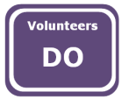   | Introduction  ‘Welcome everyone to Radio Lollipop, this great charity whose success is down to people like you, providing this unique service to sick children.’  ‘This is Radio Lollipop’s Corporate Purpose, Volunteers providing care, comfort, play and entertainment for children and young people.’  ‘It is only by you being committed to volunteering for two hours each week that we can make this happen, you are critical to Radio Lollipop’s success.’  ‘My name is (YOUR NAME)  I’m the (POSITION IN RADIO LOLLIPOP)  I have been volunteering for Radio Lollipop for (LENGTH OF TIME YOU HAVE BEEN VOLUNTEERING).’  ‘To ensure that we all feel safe and comfortable I think that it would useful to go through some housekeeping:  - Point out the safety exits  - Explain where the fire assembly point is  - Explain/point out where the toilet facilities are  - Ask for phones to be off or on silent  - Explain that we shall have coffee break mid morning and afternoon, with half an hour (ish) for lunch’  ‘Agenda  This is what we shall be doing throughout today.  - Introductions  - History of Radio Lollipop  - Structure of Radio Lollipop  - Safety  - Radio Lollipop Routines  - Management Team Roles  - Play & Radio’  ‘Team introductions  In pairs, introduce yourself to the person sitting next to you, find out the information as outlined below, then be ready to introduce your partner to the rest of the group:  - Name  - What they do outside of Radio Lollipop  - What was the reason for them joining Radio Lollipop  You have 5 minutes.  What questions do you have for me?’  Carry out the exercise.  Observe volunteers to make sure that they are comfortable with the instructions.  Take note of the time.  As soon as the 5 minutes is taken, check that the volunteers have completed the activity. If it seems that the volunteers have finished before the 5 minutes has passed gain feedback.  ‘Who would like to introduce their partner first?’  Pause and wait for someone to volunteer to introduce their partner first.  When they volunteer thank the volunteer for going first.  A volunteer offers to go first.  ‘Thank you, who will you be introducing to us?’  Listen with the intention of reflecting back what they have said, use their name etc. (This is to show that you have listened to their introduction and that you are interested).  Volunteer introduces their partner to the rest of the group.  ‘It’s good to meet you, NAME OF VOLUNTEER’, who will you be introducing?’  Repeat the above until all the volunteers present have introduced their partners.  Then issue the Radio Lollipop Volunteer Handbook with additional leaflet with the management teams, hospital and Chaplin contact details on it.  Encourage the volunteers to write their name on the front of their Volunteer Handbooks.  Open the handbooks.  ‘These packs are your guide into becoming a fully active Radio Lollipop Volunteer, we shall work through this packs throughout today. It also contains some important information to ensure we maintain Radio Lollipop standards in all that we do.’  ‘What questions do you have for me at this point?’  ‘Let’s now take a brief look at Radio Lollipop’s history.’ | On entrance show:  Slide 1 and play the most requested track of patients at the moment.  Issue the RL Volunteer Handbook for each volunteer.  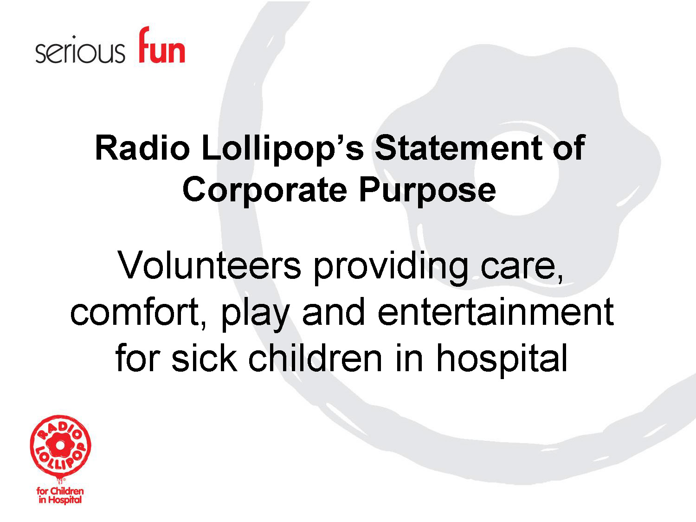Slide 1  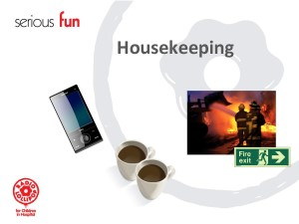Slide 2  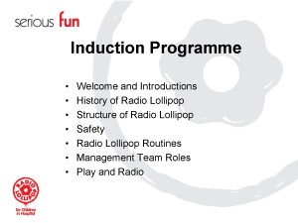Slide 3  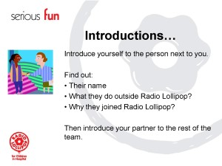Slide 4  Volunteer Handbook  Contact details sheet
10.25am-10.45am  30 mins  To understand Radio Lollipop’s background. |  | Radio Lollipop History  ‘Radio Lollipop is the brainchild of Hedley Finn and began in 1978 at Queen Mary’s Hospital for Children in Carshalton, which is about 20km south of London.’  ‘I’m pleased to introduce you to Hedley Finn.’  Play film  ‘What are your thoughts and feelings about this film?’  Listen and response to the volunteer’s thoughts and comments.  If the volunteers say nothing, then move on!  ‘After the birth of Radio Lollipop the first broadcast and play service went live at the Queen Mary’s Children’s Hospital in Carshalton on the 5th May 1979.’  ‘In 1985 Radio Lollipop grew internationally, and expanded to the Princess Margaret Hospital in Perth, Western Australia.’  ‘Since then is has growth from strength to strength with the hard work of all its volunteers.’  ‘Throughout this time Radio Lollipop’s Corporate Purpose has remained the same; Volunteers providing care, comfort play and entertainment for sick children and young people.’  ‘When people ask us what we do, we use this statement, so that we are consistent in our response.’  ‘Let’s have a go...’  Encourage the volunteers to read out the corporate purpose.  Volunteers read out the corporate purpose statement together.  ‘Well done, with a bit a practise you will soon have this down to a fine art. You can find this on page 1 in your handbook.’  ‘Let’s now take a look at how Radio Lollipop is structured.’ | Slide 5  Slide 6: Not yet created  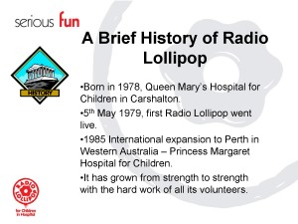Slide 7  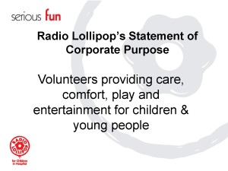Slide 8
10.45am-11am  15 mins  To gain an understanding of how Radio Lollipop functions up to an international level. |  | Structure of Radio Lollipop  ‘This is how Radio Lollipop works. Let’s start with ‘the’ most important part of the charity, the place where it all happens. This is in the stations (this is the name we give to each Radio Lollipop Team within a hospital.’  ‘The most important role within Radio Lollipop are the volunteers who provide a service directly to the children, the volunteers make the difference to a child’s life in hospital. Each volunteer have the opportunity to take the child’s mind off the reason why they are in hospital.’  ‘The volunteers who provide the children with care, play and entertainment are lead by the management team. These are volunteers who have offered to take on some additional responsibilities. There are nine post on the management team. Here are the different posts:  Chairman  Secretary  Treasurer  Play Co-ordinator  Programme Co-ordinator  Volunteer Co-ordinator  Fundraiser  Engineer  Press & PR Co-ordinator’  ‘We shall take a closer look at these posts later today.’  (Consider that International Structures may vary).  ‘The stations have support Nationally from the National Support Team, these volunteers offer specialist help and support to the stations, for example Dave Mason is our Engineering expert and ensures all our new studio’s are aligned to Radio Lollipop standards. George Williamson is our web and IT specialist and is the caretaker of the web’s content. Denise Norman is a Public Relations expert and supports the teams in gaining publicity for events that are taking place, Denise get’s involved in many others projects too.’  ‘Do you have any questions so far?’  ‘In each country where Radio Lollipop is present, the stations are supported by a Board of Trustees, these volunteers are responsible for the strategic direction of the charity, its finances, adherence to charitable legislation and well being of the services offered by all the volunteers.’  ‘Our national Board of Trustees report into the International Board, this consists of one Trustee from each country and is chaired by one person from each country and changes approximately every 2 years. Here’s who forms the International Board of Trustees.’  ‘Radio Lollipop’s official registered office is based in London.’  ‘To summarise this we have the volunteers being lead by the local management teams, who are lead by the Trustees, who are lead by the International Board of Trustees. Our official office is registered in London.’  ‘What questions do you have for me?’ | Slide 9  Slide 10  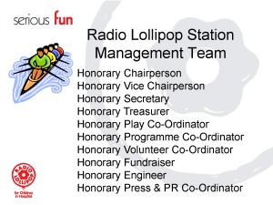Slide 11  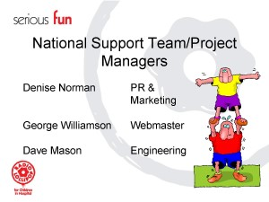Slide 12  Slide 13  Slide 14  Slide 15
11am-12.30pm  1 hour 30 minutes  To understand the partnership between Radio Lollipop and hospitals. |  | Safety  ‘We need to remember that Radio Lollipop (we are) is a guest of this hospital and any of the other hospitals where Radio Lollipop is valued. The hospital believes in the benefits that Radio Lollipop brings to the care of their patient’s.’  ‘Therefore, whenever we are on Radio Lollipop duties and wearing our Radio Lollipop uniforms we have to behave professionally in exactly the same way as any other member of hospital staff.’  ‘Just because we are volunteers this does not allow us to do as we wish. As volunteers we have agreed to donate a minimum of two hours per week to visit the children. Therefore, the expectations of the children, hospital staff and fellow volunteers are that we will do as we have said or committed to, that expectation must never be compromised.’  ‘The manner in which we conduct ourselves is also very important. We will be examining some do and don’ts later.’  ‘So, it is vital that each and every new volunteer completes the whole of the Radio Lollipop induction programme before entering the wonderful world of Radio Lollipop.’  ‘We need to work with the hospital staff, it’s a partnership. Overall we need to ensure that all parties are safe.’  ‘The three key parties are:  - you,  - the children  - and Radio Lollipop.’  ‘Let’s now take a look at the benefits and consequences of Radio Lollipop working in partnership with children in hospital.’  ‘In two groups:  Group One:  Consider - What are the benefits to the children, siblings, parents and hospital staff of having Radio Lollipop in their hospital?’  Group Two:  Consider - What are the risks of having Radio Lollipop in their hospital to the children, siblings, parents and hospital staff?’  ‘Capture the group’s thoughts on a flipchart and have one person to feedback your findings to the rest of the group. You have 10 minutes to do this exercise.’  Split the volunteers into groups of about 4-5 in each group. Half of the groups to consider the first question and the second group the second question.  Issue to each group a piece of flipchart paper and marker pens.  Check that they understand what is expected of them.  Allow 10 minutes for the volunteers to carry out the exercise.  Volunteers carry out the exercise.  ‘Good, has everyone finished. Who has the first question and is happy to share their thoughts with the rest of the group?’  Listen carefully to the findings of the group; ensure that all volunteers are respecting the volunteer who is presenting by not talking and listening to what is being said.  When the volunteer has completed, thank the volunteer and their team for their thoughts, then move on to the next group who may have the same question or move onto the question two.  ‘Thank you, (NAME OF VOLUNTEER) and your team for this. Who else has the first question?’  Repeat the above by listening carefully to the volunteer’s feedback of each of the groups. When they have all shared their thoughts see if the volunteers have anything else to add.  ‘Who was looking at question two?’  Listen carefully to the findings of the group; ensure that all volunteers are respecting the volunteer who is presenting by not talking and listening to what is being said.  When the volunteer has completed, thank the volunteer and their team for their thoughts, then move on to the next group who may have the same question.  ‘Thank you, (NAME OF VOLUNTEER) and your team for this. Who else has the second question?’  Repeat the above by listening carefully to the volunteer’s feedback of each of the groups. When they have all shared their thoughts see if the volunteers have anything else to add. Then consolidate the activity.  ‘Great work, the benefits of having Radio Lollipop is very simple and is proven that happy children get better quicker, this is of course not only good for the children, however the whole of the family. The hospitals too, and we as volunteers gain that huge ‘feel good factor’ having made a positive difference to the well being of a sick child.’  ‘The consequences on the other hand are quite dramatic if we were to get it wrong. We are working in a high risk environment, where if we didn’t adhere to hospital and Radio Lollipop guidelines we could very easily expose ourselves, the children and the hospital. The children are very vulnerable and we need to be as professional as the paid fully qualified medical staff. Hence, we are here today going though our induction.’  ‘It is our intention is to set all Radio Lollipop volunteers up for success. If you ever have any questions or queries just ask until you are confident with the information that you have received.’  ‘What questions do you have for me?’  ‘Now that we have taken a look at the bigger picture of benefits and consequences of working in partnership with hospitals we’re now going do an exercise to consider the safety of the children, Radio Lollipop and you.’  Split the volunteers into three smaller groups. Issue each team with a piece of flipchart paper and marker pen.  ‘Each group has a question to consider, as follows:  Group 1 – What do we need to do as volunteers to ensure that the children are safe when interacting with Radio Lollipop Volunteers?  Group 2 – What do we need to do as volunteers to ensure that Radio Lollipop’s reputation is safe (and maintained)?  Group 3 – What do we need to do to ensure as volunteers that we remain safe whilst on Radio Lollipop duties (and maybe beyond)?’  ‘Take 20 minutes to complete the exercise. What questions do you have for me?’  Check that they understand what is expected of them.  Allow 20 minutes for the volunteers to carry out the exercise.  Volunteers carry out the exercise.  In preparation for the groups sharing their feedback is it important the some key points are made. These points are noted below, if they are not made by the volunteers we need to highlight them, to ensure we have a consistent message for all volunteers:  Safety for the children  - Confidentiality of patents is respected (outlined with a slide)  Go through the following points:  ‘What would you do if a neighbour who knows that you volunteer at the children’s hospital, asks you about a patient who you were actually with just last night on the wards?’  Gain responses from the volunteers. Ensure that the following points are made.  ‘Any information that we become aware of with regards to the well being of the child we do not share with any other person outside of the hospital, in this situation (or any situation) we reveal nothing. We would respond with ‘I really don’t get to know about the medical side of the children, the best thing to do is ask their parents etc.’  - A children’s secret is taken by volunteers with conditions (outlined with a slide)  ‘What would you do if a child who you have become a friend of, decides that you are now their friend and say that they have a secret and ask you to promise not to tell, what do you do?’  Gain responses from the volunteers. Ensure that the following points are made.  ‘Whenever a child puts you in this situation we need to establish that it all depends on what the secret is, this ensures that you have not committed to anything and therefore you’re not breaking any trusts with the child. If the child tells you something like they have made their Mum a birthday card and its a surprise, then of course you would then agree to keep the secret. However, if the child explains that they have not taken their medication for the past two days, we need to explain to the child that we want them to get better and you need to tell the nurse so that they can help you to get better.’  ‘You will then of course tell the nurse and explain the situation, and explain that you have been told in confidence (so tell the nurse the whole story, so they can protect you and Radio Lollipop as a whole). I’m sure that they will welcome your feedback/insight.’  - We don’t lift patients  - We don’t given children any food or drink  - We gain permission from the nursing staff and parents to take a child to the Studio  - We don’t take photographs of the children without the parents written consent  - We don’t take the children to the toilet  - We adhere to infection control guidelines in the hospital  - Safe play  - All volunteers are CRB (Criminal Records Bureau/Police Check!) cleared  - Medical Clearance  Safety for Radio Lollipop  - The behaviour of any person wearing Radio Lollipop sweatshirts or t-shirts are aligned to that specified in the Radio Lollipop Volunteer role description  - The logo is not compromised  - The logo or uniform represent ‘fun’ to the children ensure that this is maintained by all volunteers  - Has a reputation which we need to maintain  - Wear the correct uniform (show slide of the correct uniform)  Safety for us  - Work in pairs  - Don’t take children to the toilet  - Be prepared to see things that we’re not used to seeing (this will be picked up in daily routines ain Radio Lollipop)  - You raise any concerns to Nursing Staff, Volunteers, Management Team, Trustee  - Correct footwear  - Attending required training  - Adhere to infection control guidelines  - Gain medical clearance before going on the wards  - Children die (Use slide and carry out next section on bereavement at the end of the exercise, when all groups have shared their feedback).  ‘Good the 20 minutes have passed, are we ready to feedback?’  Ensure that all groups are ready to feedback; allow another two minutes of more time is required.  ‘Great, would group one like to feedback first.’  Allow the volunteer to share their team’s thoughts about the safety of the children.  Listen carefully to ensure that you hear all the points that are being made, so that you may re-iterate any points or highlight any points not covered as outlined above.  Group one to share their findings.  ‘Great well done, would anyone from the other groups like to add to their comments?’  Gain any comments from the other volunteers. Allow any discussion to take place. Once you have received all the volunteers comments add any points that have not been made as outlined above.  ‘Well done group one, some great points have been made, now let’s hear what group two have discussed with regards to the safety of Radio Lollipop.’  Allow the volunteer to share their team’s thoughts about the safety of the Radio Lollipop.  Listen carefully to ensure that you hear all the points that are being made, so that you may re-iterate any points or highlight and points not covered as outlined above.  Group two to share their findings.  ‘Great well done, would anyone from the other groups like to add to group two’s comments?’  Gain any comments from the other volunteers. Allow any discussion to take place. Once you have received all the volunteers comments add any points that have not been made as outlined above.  ‘Well done group two, some great points have been made, now let’s hear what group three have discussed with regards to the safety of themselves or us.’  Allow the volunteer to share their team’s thoughts about the safety of Radio Lollipop.  Listen carefully to ensure that you hear all the points that are being made, so that you may re-iterate any points or highlight and points not covered as outlined above.  Group three to share their findings.  ‘Great well done, would anyone from the other groups like to add to group two’s comments?’  Gain any comments from the other volunteers. Allow any discussion to take place. Once you have received all the volunteers comments add any points that have not been made as outlined above.  ‘Well done group three, some great points have been made, it is worth taking a close look into some of these points to ensure that we are safe.’  ‘Very simply, toilet visits are not our/your responsibility, do not take children to the toilet, ask a member of the nursing staff if a child needs to use the toilet.’  ‘As volunteers we’re not exposed to this situation frequently, however we do need to be prepared for it, if in case we are faced with this.’  ‘We will soon get to know the patients who are frequent recipients of Radio Lollipop; quite often these children are very sick and potentially terminally ill.’  ‘There may be a time when you know the child doesn’t have long to live or in some case not.’  ‘As I’m sure you’re aware if/when we experience this loss we go through differing levels of bereavement.’  ‘In order to try and prepared us for such very sad circumstances, let’s do a quick exercise, each write down on a piece of paper the 5 most important people in your life, if you don’t have 5 people add the most important things to you to the most important people’.  Volunteers take a piece of paper and pen and write the 5 most important people and/or things in their life.  Wait for all the volunteers to have completed the exercise, which should take about 2 minutes.  ‘Now cross two of these people or things off your list.’  Pause, while the volunteers carry this out.  ‘Has everyone crossed two names of things off their list?’  Wait for the volunteers to nod or agree.  ‘Now I’d like you to cross off another two names or things off your list.’  Pause, while the volunteers carry this out. You will notice that the volunteers find this hard to do. What you are observing are volunteers grieving for the people on their list.  ‘How did you find doing this exercise?’  Gain feedback from the volunteers; allow the discussion to take its course. Consolidate the exercise by explaining that we have just experienced bereavement and that we do throughout our lives.  ‘What we have just experienced is bereavement. We do throughout our lives, let’s look at our life so far.’  ‘When we were small and with our Mum and Dad or carers, life was good until we were sent to school and had to leave Mum or Dad at the school gate, we didn’t want to leave them, we may have cried, bereavement for the loss of seeing our parents or carers all day or the life we had before school (of course some of us just skip off to have some fun with new friends). Mum and Dad may be experiencing bereavement in the loss of seeing their child every minute of each day.’  ‘When we have pets that pass away, we experience bereavement.’  ‘When we move house and leave of home which is full of happy memories, we experience bereavement.’  ‘When we change our cars that we’ve relied on for years, we experience bereavement.’  ‘When leave home to get married or go to university, we experience bereavement.’  ‘When our grandparents pass away, we experience bereavement.’  ‘When we become Radio Lollipop volunteers we may experience bereavement.’  ‘It is important to know that there is support for you in case of these circumstances, our de-brief that forms part of our daily Radio Lollipop routine is critical to share what you’ve learned or experienced during your session on the wards. The hospital offers support for loss too. Or make contact with a member of the management team that you feel comfortable to talk to about this.’  ‘The most important point is not be alone, share your feelings, it’s ok...its natural.’  ‘To complete this safety session, please take some time to read through the do’s and don’ts on page 14 & 15 in you volunteer guidelines of your information pack.’  ‘What questions do you have for me?’  Respond to any questions that the volunteers may have.  ‘Let’s take 30 minutes for lunch.’ | 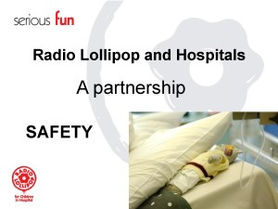Slide 16  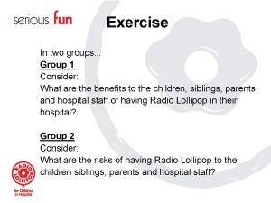Slide 17  Flipchart paper & pens  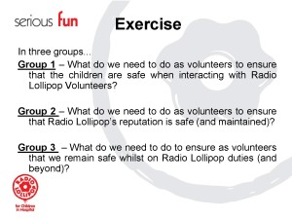Slide 18  Flipchart & marker pens  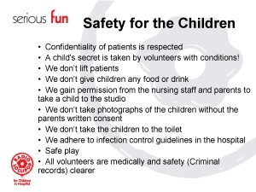Slide 19  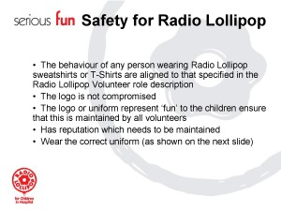Slide 20  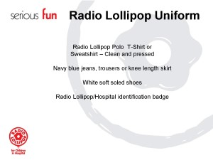Slide 21  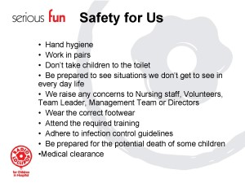Slide 22  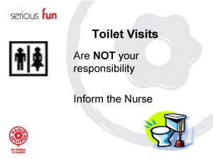Slide 23  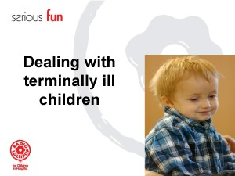Slide 24  Paper & pen  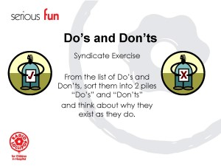Slide 25  Volunteer Guidelines  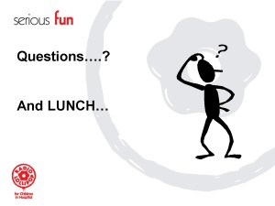Slide 26
12.30pm-1pm  30 minutes  Light refreshment and social chat |  | Lunch
1pm-2pm  1 hour  To have an insight of what life in Radio Lollipop |  | Radio Lollipop Routines  Daily Routines  ‘In Radio Lollipop we have routines that support the safety and well being of all parties. All routines are there with a purpose to support us all in maintaining standards and safety.’  ‘Let’s start with what happens each night or day when we are ward visiting.’  ‘We are live on the wards on (SPECIFY THE DAYS AND TIMES FOR YOUR STATION)’  ‘Every evening has a structured approach to it, although the content can at times be totally unstructured, which is all part of the fun.’  ‘It is vital that we arrive about 15 minutes before Radio Lollipop goes live to gain a briefing of what is happening for the night.’  ‘It will be the Team Leader and presenter who lead the briefing and de-brief. The Team Leader supports the Volunteer Co-ordinator in maintaining communication links with the volunteers visiting on each night.’  ‘In two groups consider the following questions:  Group One: What information do you believe that you would need before going on to the wards for the evening? How may this help you and others i.e. the children, the volunteers, the presenter, the siblings, parents, nursing staff and Radio Lollipop?  Group Two: What information do you believe that you would need to share as part of the end of session de-brief after going on the wards? How may this help you and others i.e. the children, the volunteers, the presenter, the siblings, parents, nursing staff and Radio Lollipop?’  ‘You have 15 minutes to complete the exercise, capture your thoughts on a flipchart and have one person to present your findings to the rest of the group.’  ‘What questions do you have for me?’  Check that the volunteers understand what is expected of them.  Allow 15 minutes for the volunteers to carry out the exercise.  Ensure the following points are made for the group feedback  Group One – Briefing:  - Themes for the night, some idea of how to create any craft activity  - What phone in competition will be taking place and when  - If there are any children to look out for i.e. would are bored, sick or in need of extra attention  - If there is anything to be concerned about i.e. seriously sick child  - Who is going to work on which ward  - Who is working with who  - All volunteers signed in  - The routine when on the wards – Buzz (intercom) into the ward, introduce yourself, see nursing staff to enquire who may like/need Radio Lollipop or not.  Group Two – De-briefing:  - Who they have worked with, age, sex of child  - Who received prizes  - Any concerns i.e. sick children  - Who i.e. which patients the next Radio Lollipop volunteer may need to look out for  - What went well on the wards, celebration and magical moments  - What didn’t go so well  - What could be done differently to improve the service  - Capture data of the number children, age and prizes for Radio Lollipop information  - All volunteers sign out  Ensure that all groups are ready to feedback; allow another two minutes if more time is required.  ‘Great, would group one like to feedback first.’  Allow the volunteer to share their team’s thoughts about the information they believe that they would require before going on the wards and how this would impact on others.  Listen carefully to ensure that you hear all the points that are being made, so that you may re-iterate any points or highlight and points not covered as outlined above.  Group one to share their findings.  ‘Great well done, would anyone from the other groups like to add to their comments?’  Gain any comments from the other volunteers. Allow any discussion to take place. Once you have received all the volunteers comments add any points that have not been made as outlined above.  ‘Well done group one, some great points have been made, now let’s hear what group two have discussed with regards to what information that you believe that you would need to share as part of the de-brief and how this may impact on others.’  Allow the volunteer to share their team’s thoughts about the information they would share at the end of session de-brief and how this may impact on others.  Listen carefully to ensure that you hear all the points that are being made, so that you may re-iterate any points or highlight and points not covered as outlined above.  Group two to share their findings.  ‘Great well done, would anyone from the other groups like to add to group two’s comments?’  Gain any comments from the other volunteers. Allow any discussion to take place. Once you have received all the volunteers comments add any points that have not been made as outlined above.  ‘Should you have any concerns you’d like to talk about, please go to your Team Leader, they are there to help. Alternatively contact the Volunteer Co-ordinator, or anyone on the management team. You can talk to them in confidence; please do not feel alone, worried or concerned.’  ‘Remember to never be on a ward alone, we must always visit the wards in pairs and not leave each other alone on the wards and of course to have loads of fun.’  Monthly Routines  ‘Communication is important to ensure so that we can maintain a high standard of service to the children. Therefore, all volunteers are encouraged to attend the Volunteers Meetings which the management team organise, ideally every month. Your contributions in these meetings are crucial. Our next meeting is....’  ‘The management team are required to complete monthly reports which feed into the quarterly report used by the Trustees, this is used to establish the service levels that Radio Lollipop are offering to the hospitals, and contribute to potential future growth, funding and sponsorship. Therefore, when we sign in and out, share information on the children all help to develop and grow, so that we can eventually reach more sick children across the world and improve the service that we provide.’  Quarterly Routines  ‘To ensure that you are supported as new volunteers and that we are all meet the required level of service to the children as Radio Lollipop volunteers, we all will have a ‘Probationary Review.’  Issue Probationary Review document.  ‘The most valued part of this review is for your Team Leader or Volunteer Co-ordinator to gain your in-sight and feedback for ideas in how we can improve the service that we offer.’  ‘Volunteer reviews will take place every 6 months, so that we keep on track and provide consistent high standards of service throughout the whole of Radio Lollipop as one team.’  ‘The management team compile a quarterly report which is submitted to the Board of Trustees, who use this information to measure Radio Lollipop’s effectiveness. This assists in assessing quality, quantity of recipients of our service, assists when gain potential funding, sponsorship and new services to additional hospitals.’  Every Six Months/Twice a year  ‘As mentioned above we shall all receive feedback on how we’re doing, along with an opportunity to share any ideas in how we can improve the service that we provide.’  ‘This is also an opportunity for your Team Leader to ask or see if you may be interested in assisting the management team, we know that we have huge talent within our teams. We always need additional support to expand our service to the children’  ‘What are your thoughts about having a regular review with your Team Leader or Volunteer Co-ordinator?’  Gain the volunteers thoughts about this and allow the discussion to take place and respond appropriately. Remain clear that the purpose of the review is all about ensuring that we all maintain the high standards within Radio Lollipop, so that Radio Lollipop as a service and brand is connected to quality.  ‘The chairmen attend a meeting with the Trustees once every 6 months, to encourage open communication and to keep chairmen up to date with Radio Lollipop’s national and international strategy.’  ‘The Trustee’s meet every quarter, four times each year.’  Annual Routine  ‘Once a year all management teams meet for each country for a Training weekend. The purpose of this is to ensure best practise across Radio Lollipop. It is a great opportunity to share experiences and expertise.’  ‘This takes place over a weekend, is great fun, inspiring and re-aligns our activity for the new year.’  ‘What questions do you have for me about Radio Lollipop Routines?’  Gain responses from the volunteers and respond appropriately. | 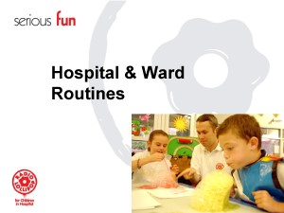Slide 27  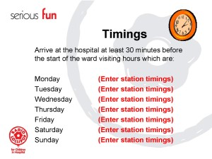Slide 28  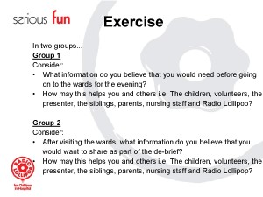Slide 29  Flipchart & pens  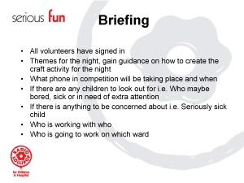Slide 30  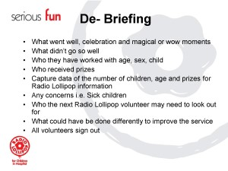Slide 31  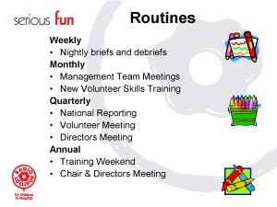Slide 32  Date of the next Volunteers Meeting  Probationary Review document
2pm-2.45pm  45 minutes  To gain an understanding of what each management posts does |  | Our Management Team  ‘Now to take a closer look at our management teams.’  ‘In groups we each shall take a look at one or two of the management posts, and explore what the key responsibilities are for each post, here are one or two as an example:  Chair men  Key responsibilities:  - Leadership of the station  - Maintaining standards  - Progress of the station  - Ensuring that policies and procedures are followed  - Quarterly and annual reporting  Secretary  Key responsibilities:  - Ensuring clear communication is maintained for the station and outside the station  - Monitoring of mail  - Compilation of minutes and issue of minutes  - Preparing reports’  ‘In groups of three or four, take a look at each postholders role description. Detail on flipchart, for each post:  - The purpose of the post  - The key responsibilities of each post  Feedback your findings to each group, you have 20 minutes to complete the exercise.’  Allocate evenly the following posts to the volunteers in groups of three or four volunteers in each group:  - Treasurer  - Volunteer Co-ordinator  - Play Co-ordinator  - Programme Co-ordinator  - Press & PR Co-ordinator  - Fundraiser  - Engineer  Issue flipchart paper and marker pens, issue the role descriptions to the appropriate group of volunteers.  Allow 15 minutes for the volunteers to carry out the exercise.  Ensure that all groups are ready to feedback; allow another two minutes if more time is required.  ‘Good, who would like to feedback first.’  The first group the volunteer is to share their findings/thoughts.  Listen carefully to ensure that you hear all the points that are being made, so that you may re-iterate any points or highlight and key points not covered as outlined on the role description.  ‘Great well done, who would like to feedback next.’  Repeat the feedback format until all group have shared their finding/thoughts.  ‘I think that by now we should have a good idea of how our station operates, as mentioned earlier if you would like to offer more time and your services to Radio Lollipop our management team are keen to share some of their responsibilities. So, if you’d like help just speak to any of the management team, their email addresses are in your information pack or speak to me at the end of today’s session.’  ‘What questions do you have for me about our management team?’  Gain responses from the volunteers and response appropriately. | 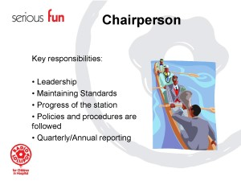Slide 33  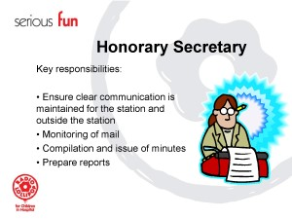Slide 34  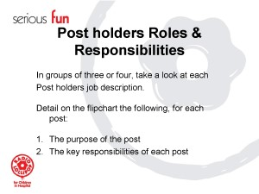Slide 35  Flipchart & marker pens  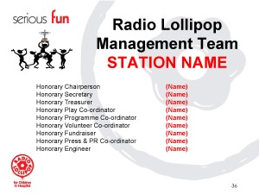Slide 36
2.45pm-4pm  1 hour 15 minutes  To experience how radio & play work together |  | The magic of play & radio  ‘At last it’s time for some serious fun! We have already mentioned that each night during our briefing before going on the wards we have the theme for the night shared with us, along with the phone in etc.’  ‘In groups we’re going to create a theme for use on the wards the following things need to be considered:  Activities to suit the following age groups (boys and girls)  - 0-5 years  - 6-11 years  - 12+years  - Music to be played to support the theme  - 2 phone in competitions  - And what the prizes may be aligned to the theme  (NAME OF PRESENTER EXPERT & VOLUNTEER) is here to assist you to select your music.  You have 30 minutes to come up with your theme and present to the rest of the group.’  ‘What questions do you have for me?’  Check the volunteers understand what is expected of them.  Allow 30 minutes for the volunteers to carry out the exercise.  Support the teams with the activity, inspire them wherever possible.  Ensure that all groups are ready to feedback; allow another two minutes if more time is required.  ‘I can’t wait to hear about these fantastic new themes we can take onto the wards to the children, who would like to share their themes first?’  Listen carefully to ensure that you hear all the points that are being made, so that you can make comment about the theme.  Encourage a round of applause for the volunteer’s efforts.  ‘Wow, this is fabulous, well done the children will love this.’  ‘Who is going to feedback next?’  Repeat the feedback for each of the groups themes, until all groups have feedback.  ‘What questions do you have for me with regards to play and radio?’  Gain responses from the volunteers and response appropriately.  ‘It’s important that play & radio work together and complement each other on the wards. Remember any patient who is well enough to visit the studio should/can be encouraged to visit the studio; they can even become a presenter for the night or be the presenter’s assistant. When this happens the children really do get the best out of Radio Lollipop.’ | 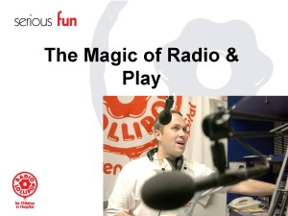Slide 37  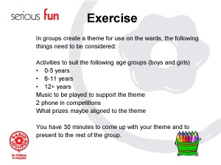Slide 38  Craft trolleys & materials
4pm-4.30pm  30 minutes  To close the day and complete any necessary administration for ward visiting |  | Close & feedback  ‘Well that just about it for today has everyone signed in?’  ‘It would be great if you’d be happy to share some feedback about the day, so that we can learn from your experience and see if there are ways that we can make any improvements.’  Issue feedback forms and pens.  Allow 5 minutes for the volunteers to complete their feedback sheets in.  ‘Thank you for this.’  ‘What other questions may you have for me before we leave for the day?’  Gain responses from the volunteers and response appropriately.  ‘Thank you for your time and I look forward to seeing you on the wards. It’s great that you have joined Radio Lollipop.’ | NPS feedback form  Slide 39  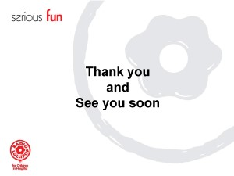Slide 40

